Sick, Shut-in and Prayers
Mothers of Ascension Fellowship, *All Ascension Fellowship Students

Events and Programs
April Birthdays and Anniversaries: A big shout out to those celebrating birthdays and Anniversaries this month.
Learning is Growing: Join us for Sunday School every Sunday at 9:00 am. All are welcome. Bible Study is held every Wednesday at 6:00 pm. Please check your email for Microsoft Teams link to join.
Online Women's Prayer Meeting - Tuesdays at 7:00pm: To join the prayer meeting, type the following meeting link into your browser: https://meet.google.com/rtt-crdv-ngo
ALL WOMEN: are invited to participate in the Women's Day Choir. Our next rehearsal will be on Saturday, May 4, 2024, at 10:30am.
AFC Women’s Ministry Presents: “The Power of a Woman’s Prayer Luncheon” @ Ascension on Saturday May 18, 2024, from 12:00 P.M. – 2:30 P.M. Guest Speakers will be Pastor Carolyn Pearson Harris of King of Glory MKE and Pastor Valaine Graham-Hill of Faith Church Milwaukee. Tickets are $20.00 per person. For more information, please see Sister Santosha Landon-Tillman.
Annual Women’s Day : will be held on Sunday May 19, 2024 @ 10:00 A.M. Worship Service. The Guest Speaker is Dr. Brenda L. Kearney. The afternoon program will be @ 3:30 P.M. with Guest Speaker Pastor Drina Lewis.
The Higher Education Committee: ask that students/parents complete a student information form and submit them no later than May 26, 2024, for Student Recognition Day on June 9, 2024. For more information, please contact Sister Tuwania Anderson.
Additional Announcements: Use your smartphone to scan the QR Code for access to quick links and more information.

Ascension Fellowship Church

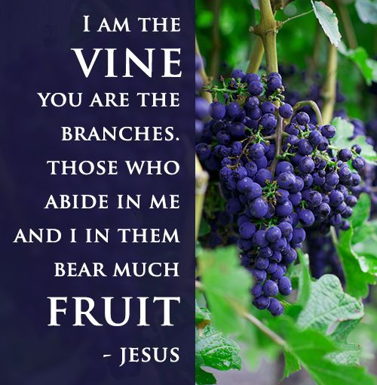

2429 West Hampton Avenue, Milwaukee, Wisconsin 53209 Phone: 414-378-4031 Email: admin@ascensionfellowshipchurch.org Website: www.ascensionfellowshipchurchmke.org Reverend Marvin G. Spence – Pastor Reverend Richard Strode – Assistant Pastor
Welcome To Our Church
Sunday April 28, 2024

Sunday School 9:00 am – 9:45 am
Praise & Worship 9:50 am Worship Service 10:00 am

*Please stand as you are able

Praise & Worship
Greeting
*Responsive Reading Psalm 22:25-31
* Opening Prayer
New Testament Reading 1 John 4:7-21
Music Ministry
Announcements
Recognition of Visitors
Celebration of Giving (Offering)
Pastoral Prayer
*Gospel Reading John 15:1-8
Music Ministry
The Message “Checking My Spiritual Connection”
Pastor Richard Strode Sr.
*Invitation/ Discipleship
*Closing Hymn
*Benediction

Psalm 22:25-31 (NIV)
²⁵ From you comes the theme of my praise in the great assembly;
before those who fear you^{[a]} I will fulfill my vows.
²⁶ The poor will eat and be satisfied; those who seek the Lord will praise him—may your hearts live forever!

²⁷ All the ends of the earth will remember and turn to the Lord, and all the families of the nations will bow down before him,
²⁸ for dominion belongs to the Lord and he rules over the nations.

²⁹ All the rich of the earth will feast and worship; all who go down to the dust will kneel before him—those who cannot keep themselves alive.
³⁰ Posterity will serve him; future generations will be told about the Lord.
³¹ They will proclaim his righteousness, declaring to a people yet unborn:
He has done it!

