Sick, Shut-in and Prayers
Mothers of Ascension Fellowship, *All Ascension Fellowship Students

Events and Programs
April Birthdays and Anniversaries: A big shout out to those celebrating birthdays and Anniversaries this month.
Learning is Growing: Join us for Sunday School every Sunday at 9:00 am. All are welcome. Bible Study is held every Wednesday at 6:00 pm. Please check your email for Microsoft Teams link to join.
Online Women's Prayer Meeting - Tuesdays at 7:00pm: To join the prayer meeting, type the following meeting link into your browser: https://meet.google.com/rtt-crdv-ngo
ALL WOMEN: are invited to participate in the Women's Day Choir. Our next rehearsal will be on Saturday, May 4, 2024, at 10:30am.
AFC Women’s Ministry Presents: “The Power of a Woman’s Prayer Luncheon” @ Ascension on Saturday May 18, 2024, from 12:00 P.M. – 2:30 P.M. Guest Speakers will be Pastor Carolyn Pearson Harris of King of Glory MKE and Pastor Valaine Graham-Hill of Faith Church Milwaukee. Tickets are $20.00 per person. For more information, please see Sister Santosha Landon-Tillman.
Annual Women’s Day : will be held on Sunday May 19, 2024 @ 10:00 A.M. Worship Service. The Guest Speaker is Dr. Brenda L. Kearney. The afternoon program will be @ 3:30 P.M. with Guest Speaker Pastor Drina Lewis.
The Higher Education Committee: ask that students/parents complete a student information form and submit them no later than May 26, 2024, for Student Recognition Day on Sunday June 9, 2024. For more information, please contact Sister Tuwania Anderson
Additional Announcements: Use your smartphone to scan the QR Code for access to quick links and more information.

Ascension Fellowship Church

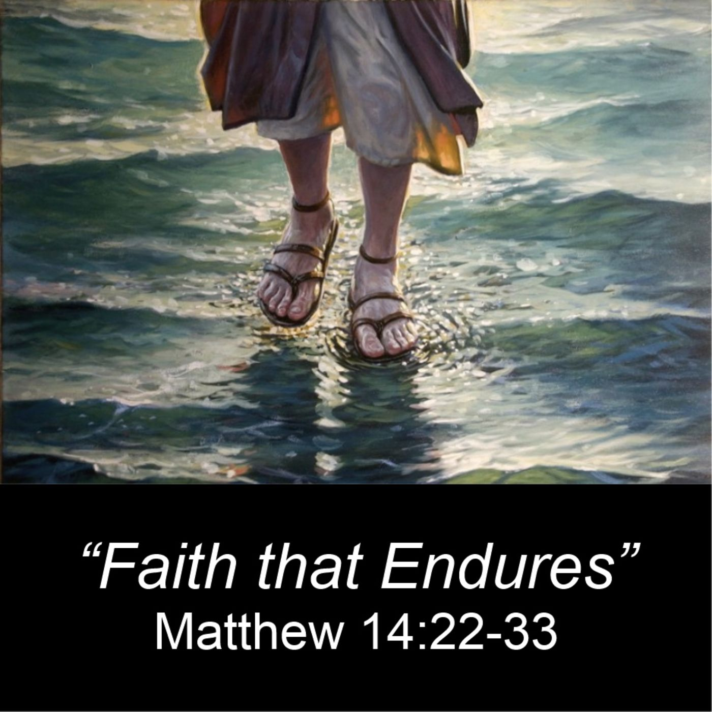

2429 West Hampton Avenue, Milwaukee, Wisconsin 53209 Phone: 414-378-4031 Email: admin@ascensionfellowshipchurch.org Website: www.ascensionfellowshipchurchmke.org Reverend Marvin G. Spence – Pastor Reverend Richard Strode – Assistant Pastor
Welcome To Our Church
Sunday April 21, 2024

Sunday School 9:00 am – 9:45 am
Praise & Worship 9:50 am Worship Service 10:00 am

*Please stand as you are able

Praise & Worship
Greeting
*Responsive Reading Psalm 23
* Opening Prayer
New Testament Reading 1 John 3:16-18
Music Ministry
Announcements
Recognition of Visitors
Celebration of Giving (Offering)
Pastoral Prayer
*Gospel Reading Matthew 14:22-33
Music Ministry
The Message “Faith Outside the Boat”
Reverend John K. Patterson
*Invitation/ Discipleship
*Closing Hymn
*Benediction

Psalm 23 (KJV)
The Lord is my shepherd; I shall not want.
² He maketh me to lie down in green pastures: he leadeth me beside the still waters.
³ He restoreth my soul: he leadeth me in the paths of righteousness for his name's sake.
⁴ Yea, though I walk through the valley of the shadow of death, I will fear no evil: for thou art with me; thy rod and thy staff they comfort me.
⁵ Thou preparest a table before me in the presence of mine enemies: thou anointest my head with oil; my cup runneth over.
⁶ Surely goodness and mercy shall follow me all the days of my life: and I will dwell in the house of the Lord forever.

